SILLY MISTAKES

- Answer kitne decimal place tk likhna hai?
- Percentage pucha hai ya actual value ?
- Value decimal me likhni hai ya binary me ?
- Ques me bits required pucha hai ya bytes?
- If and only if means dono side se true hona chahiye... options acche se padho.
- In case of DFA... epsilon dekha karo pehle..if epsilon accepted then first state is accepting state.
- DFA me Agar *not* containing something pucha hai to pehle normal dfa banao of uska complement kr do.
- Set of all formal languages = set of all recursively enumerable language.
- Minimum no of gates required?
pehle acche se minimize karlo uske baad gates dekho...kabhi kabhi its a tautology or fallacy to zero gates required
- View serializability check krne k liye pehle check karo are there any blind writes? If not, then it's not view serializable.
- Program k output wale ques me pehle check karo koi error to nhi hai
Like kisi array k base address ko increment ho raha ho
Int A[10];
A++;
Error is there.
- Substring count krte time ‘n’ length wali string bhi count krte hai.
Eg: substrings of ‘aab’ = {a, aa, ab, aab}.
- In the context of pointers…when it is given
int *p=1000;
cout<<*(p+1); //here you have to access the memory location 1004 but not change the value of p.
cout<<*(++p); //here you have to access the memory location 1004 and also change the value of p to 1004. 0.25,0.005,0.0025,etc are not less than zero. In one of the question, inside if condition it is given like this : if(n<0){ }

N is tending to zero but will never be less than zero. Jldi jaldi me mene 0.25<0 true kar diya.
- In finding dual of a function, change + to . and vice versa. Also change 0 to 1 and 1 to 0 but do not change a variable to its complement ie: A’ will remain A’ in dual.
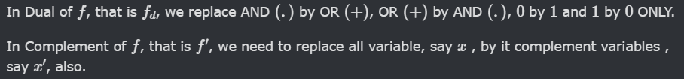
- Buffer and NOT gate look exactly similar. Only difference is that there is a bubble in the NOT gate. Be attentive!
- MUX k input lines check karo pehle kis order me diye hai MSB LSB.
- In the case of logic gates, “delay” and “stable” are different things.
These two are different question :
- What is the delay of the following gate?
- At what time the output of the gate is stable?
Check digital ka google doc, one question is there.
- Difference between subsequence and substring.
Subsequence is a sequence that may not be consecutive and substring must be consecutive.
“ABCDEFG” : Here ADF is a subsequence and CDE is a substring.
- Check the order of MSB and LSB in the answer of flipflops ie. Q₀Q₁ or Q₁Q₀,etc.
- Beware of these games : O(1)=O(logn)= O(n),etc
- DBMS me jab file indexing k liye no of blocks vagera calculate kret hai to direct total file size nikal k block size se divide nahi karna hai.
Instead pehle block factor nikalo uske baad file size ko block factor se divide karo.
Try to solve this : https://gateoverflow.in/2311/gate-cse-1993-question-14
- Combinatorics me always do the “at least one” type k questions complement logic se hi krna !
- Rooted tree is a directed graph while Tree is an undirected graph.
- While performing stack based subtraction and division the order will be determined as : a-b mtlb pehle a push hua phir b to pop krke time 1st operand will be subtracted from second.
- Line size matlab block size ! (in cache )
- No of cache lines means No of blocks or sets in cache.
- Graph theory mein kisi bhi question me check for connected and disconnected graph wale cases.
- 100 times faster means T_{new =} T_{old} / 100 (speedup)
- 100% faster means T_{new =} T_{old} / 2
- 50% faster means T_{new =} T_{old} / 1.5
- 200% faster means T_{new =} T_{old} / 3
- Simply if the old speed was x and if it is increased by 50% then
- S_{new}= S + (50/100)S = 1.5 * S
https://gateoverflow.in/380480/go-classes-test-series-2023-and-architecture-test-question
- 1 + 1/2 + 1/3 + 1/4 +.... + 1/n = logn
- Let S = { 1,2 } then P(S) = { ϕ , {1 } , {2} , {1,2} }
This is wrong : P(S) = { {ϕ} , {1} , {2} , {1,2} }

- In discrete maths, propositional variable and propositional formula are two different things.
- No of probes in hashing means the no of times you have calculated the hash function (not the no of collisions)
- Dual of a function = (complement ka reverse)
- Decoder m ya kisi bhi circuit me MSB LSB ka dhyan rakho.

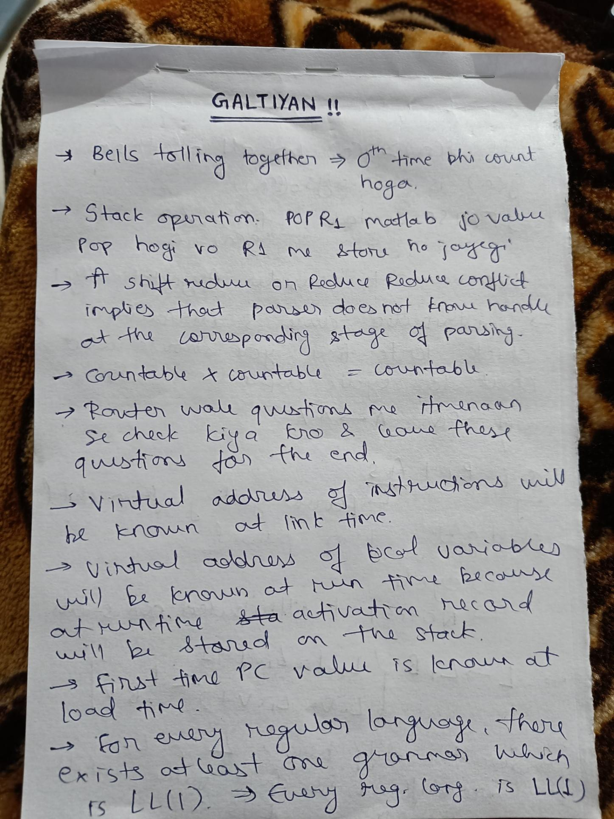
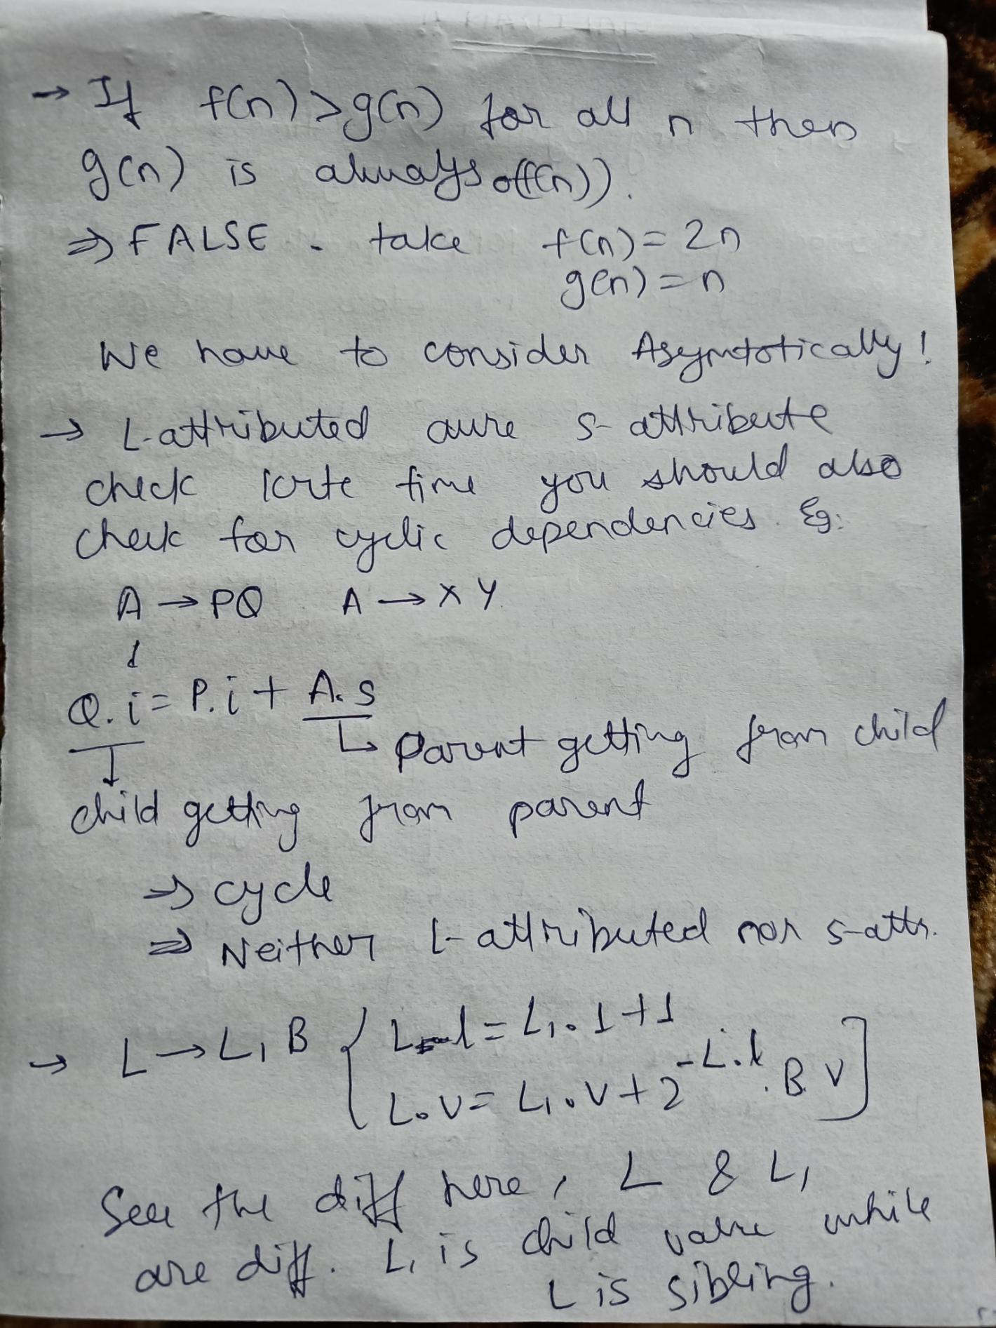
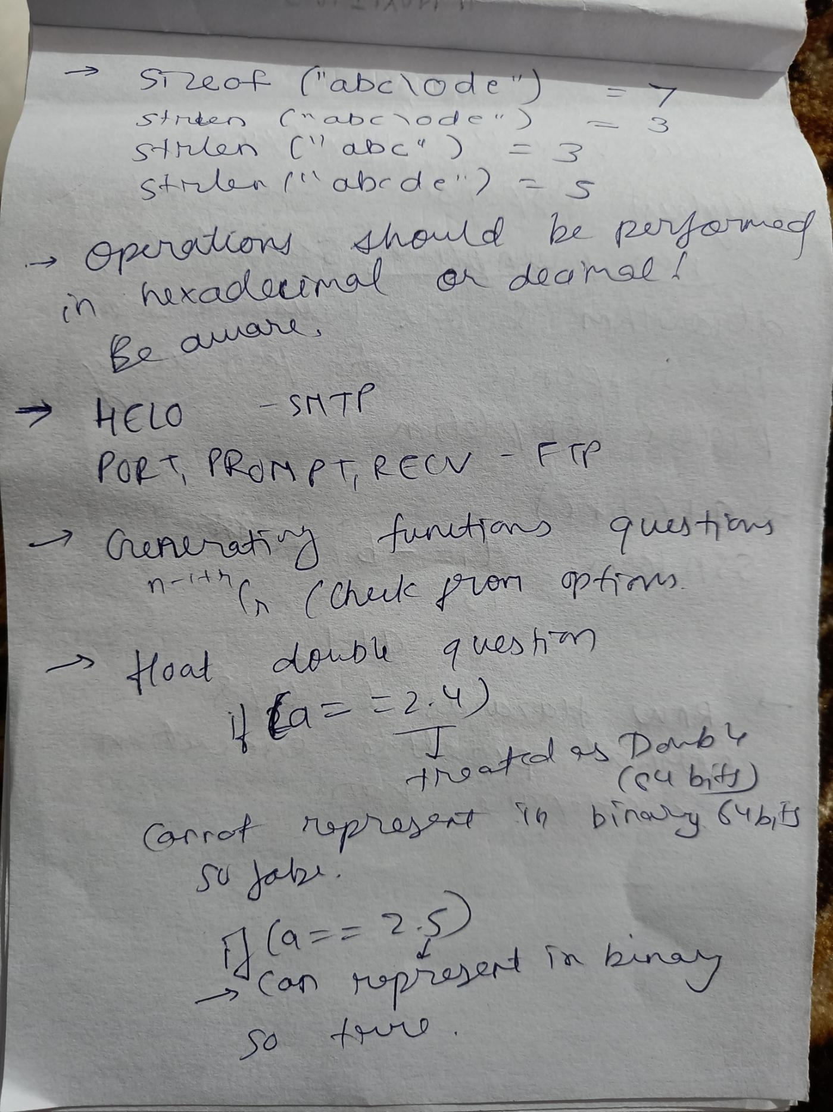
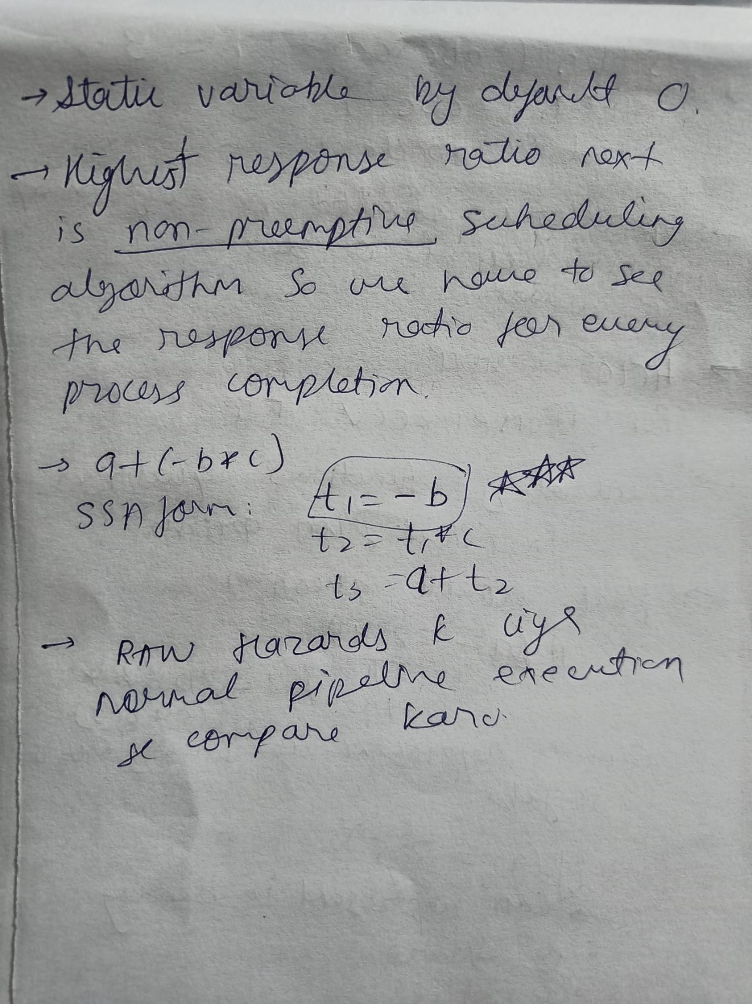
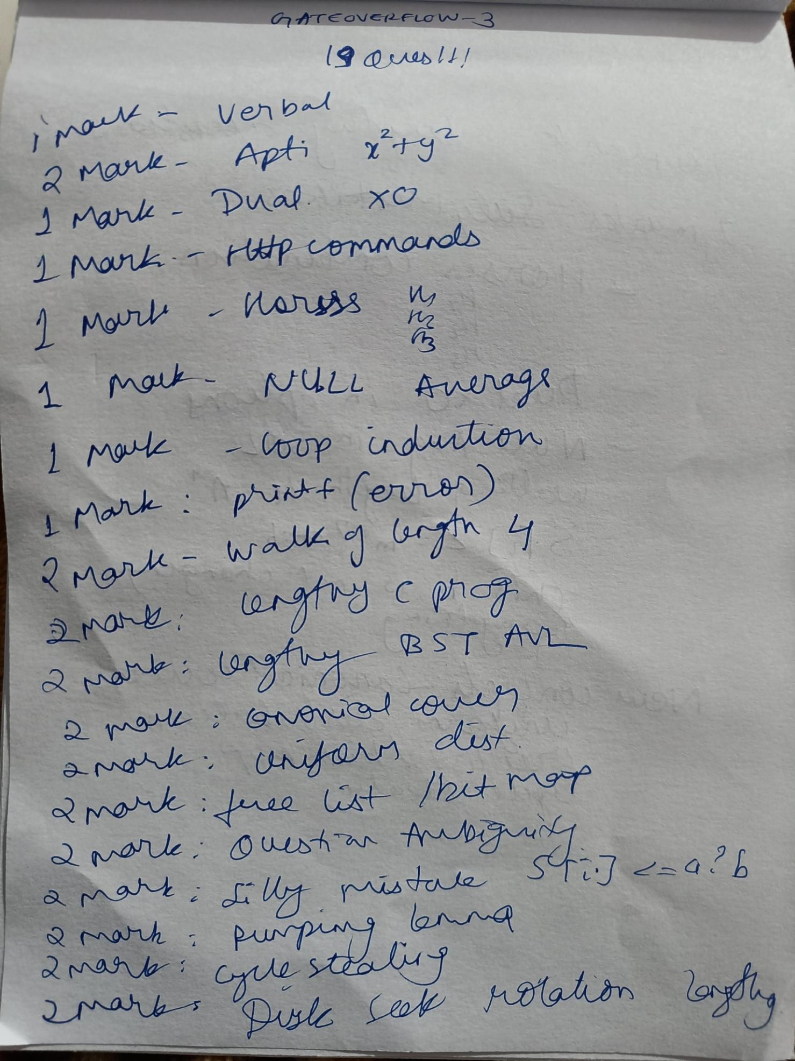
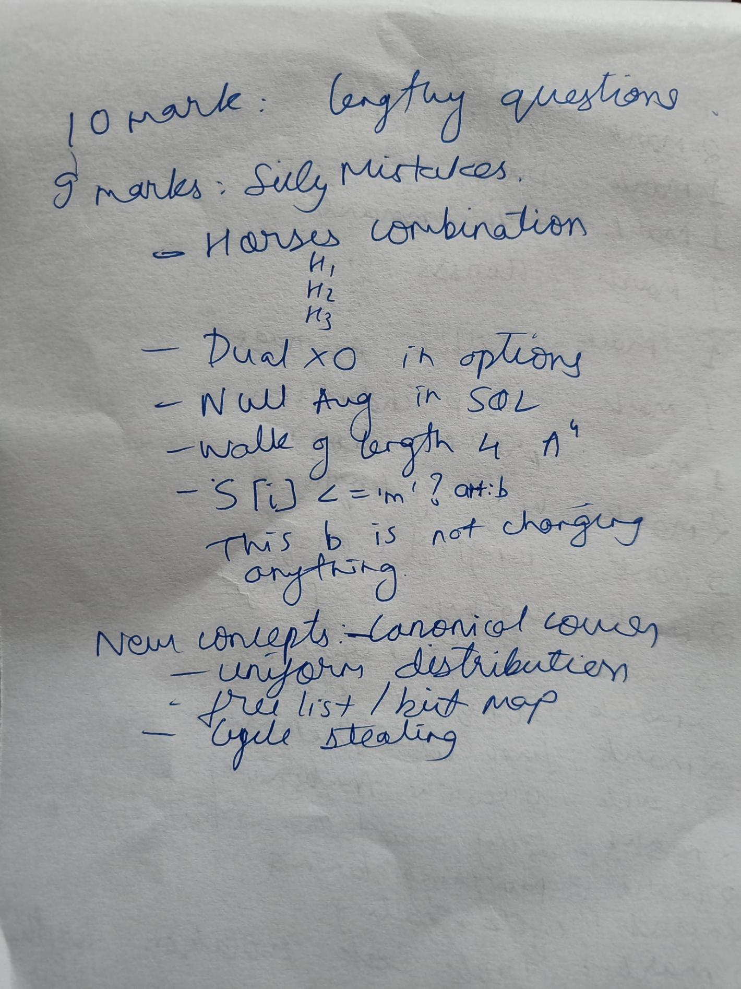

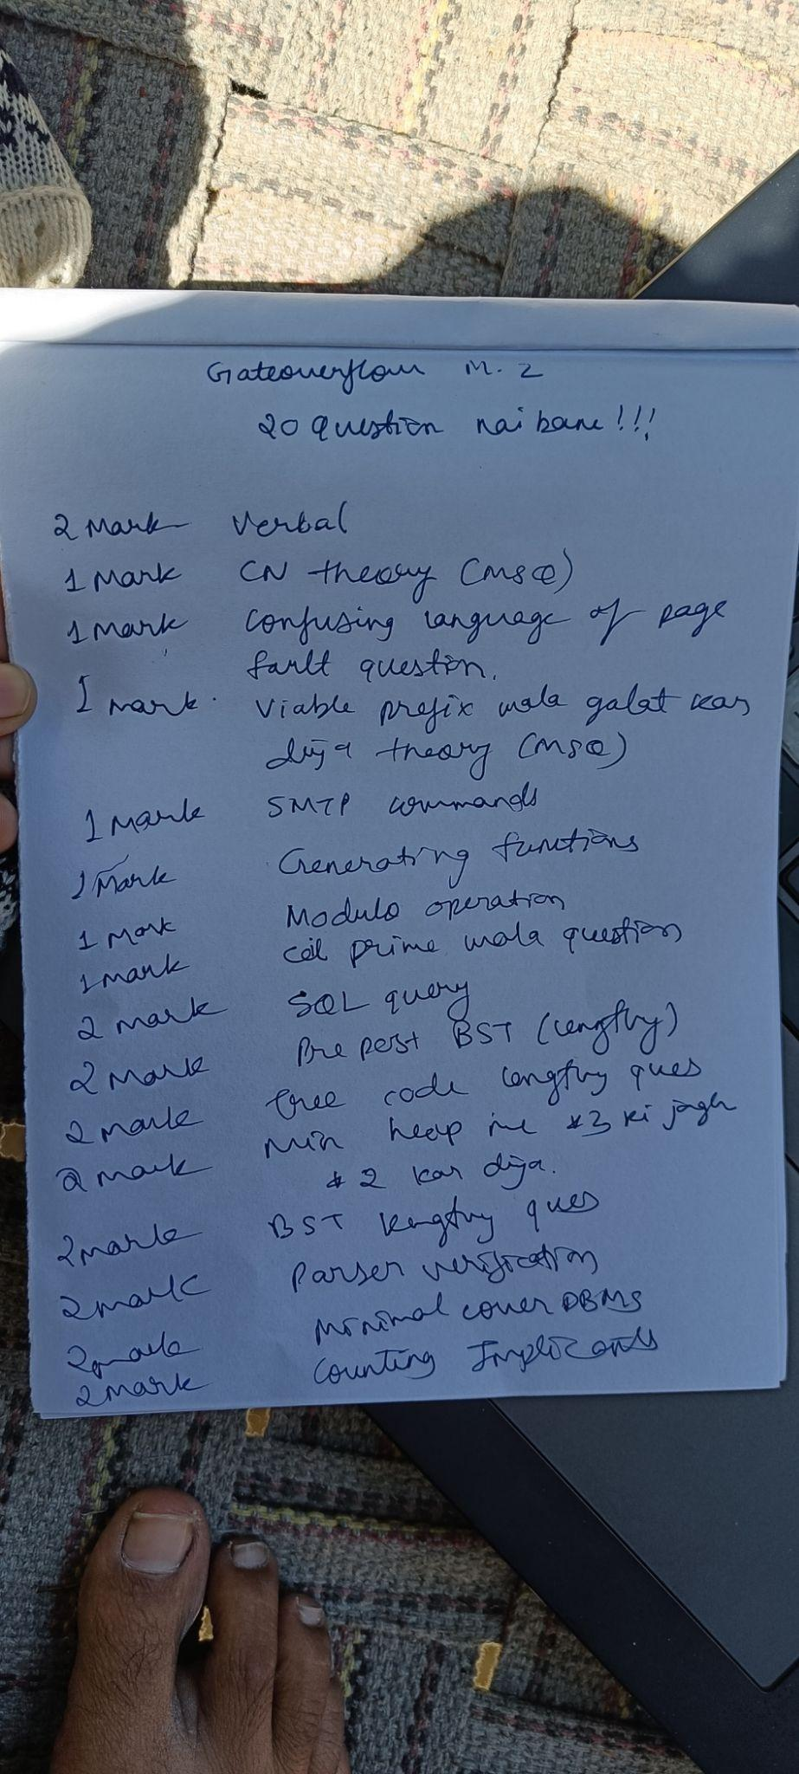
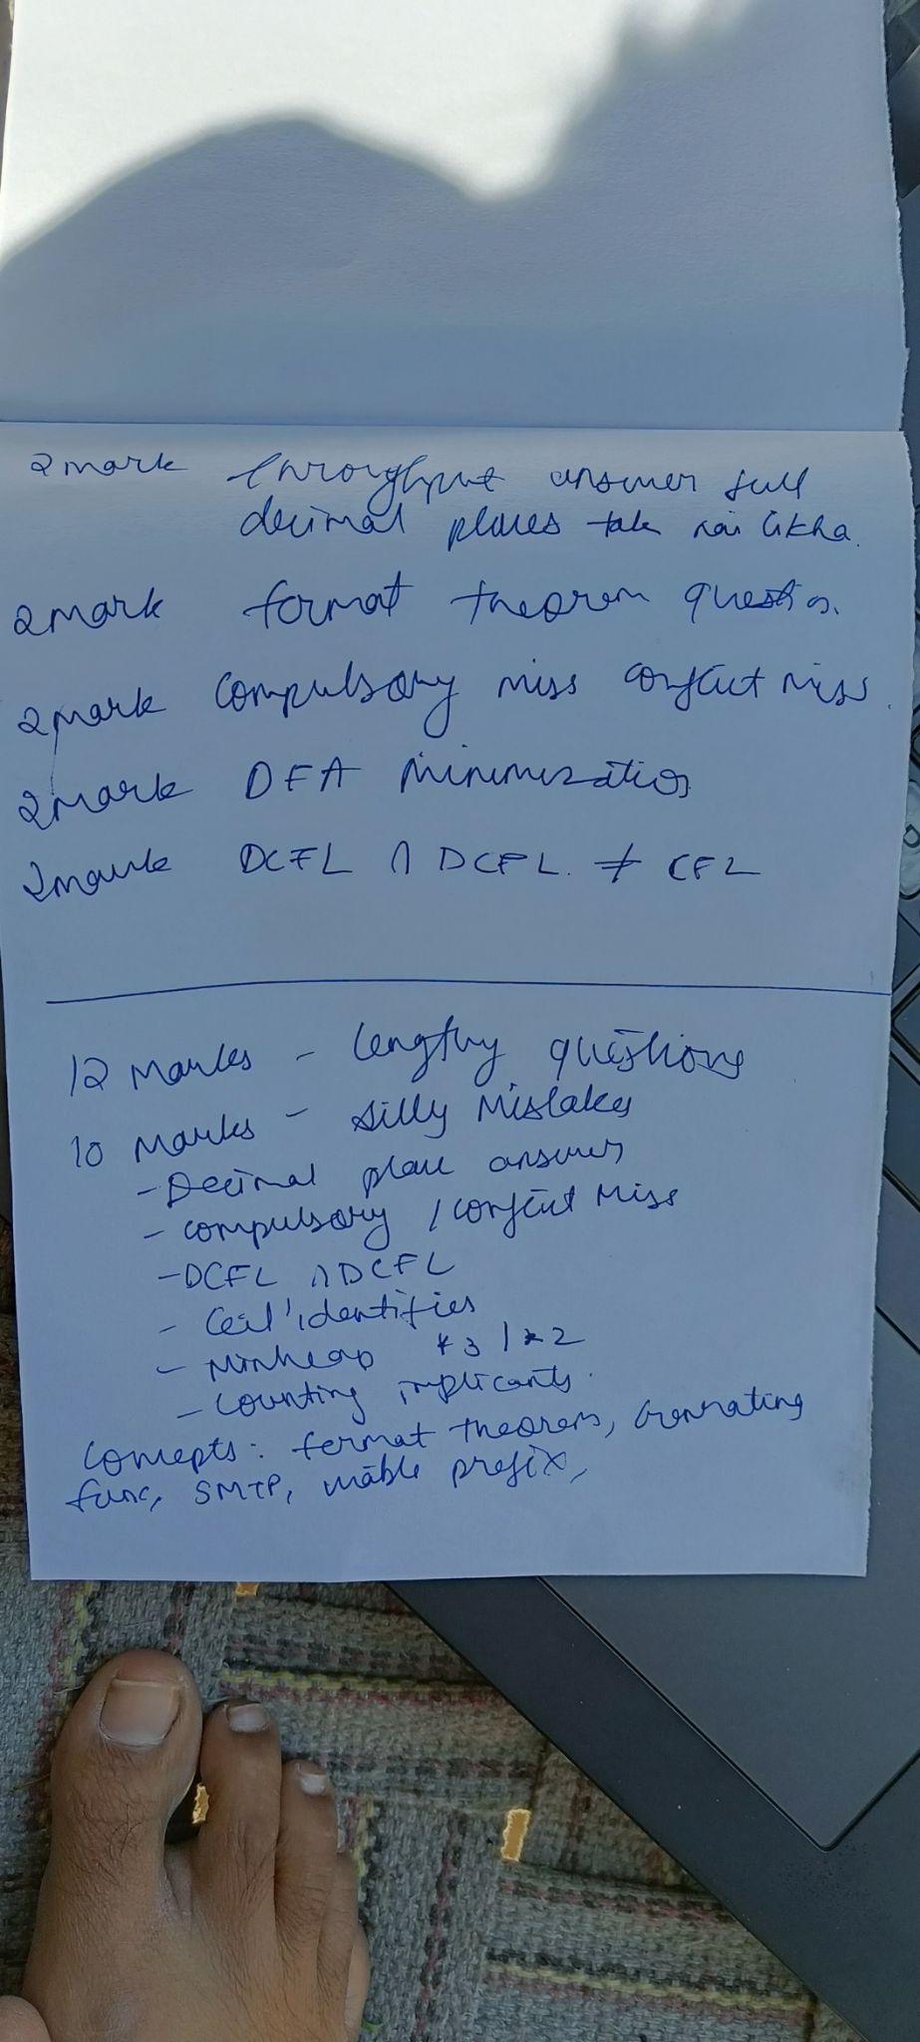

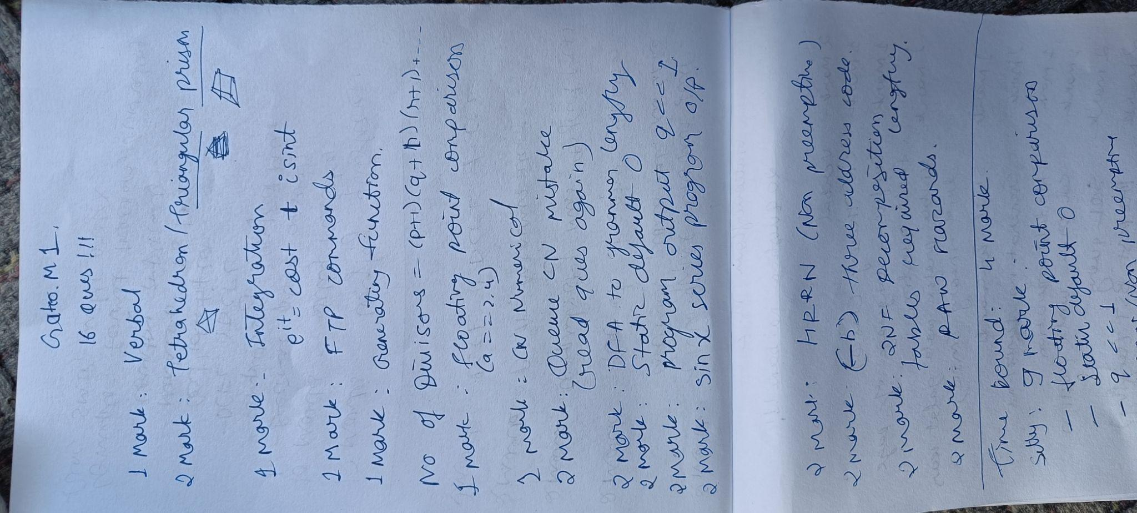
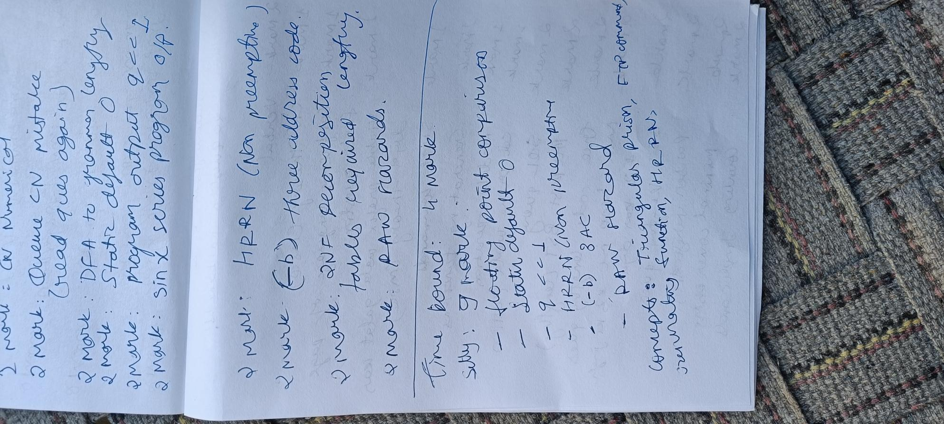
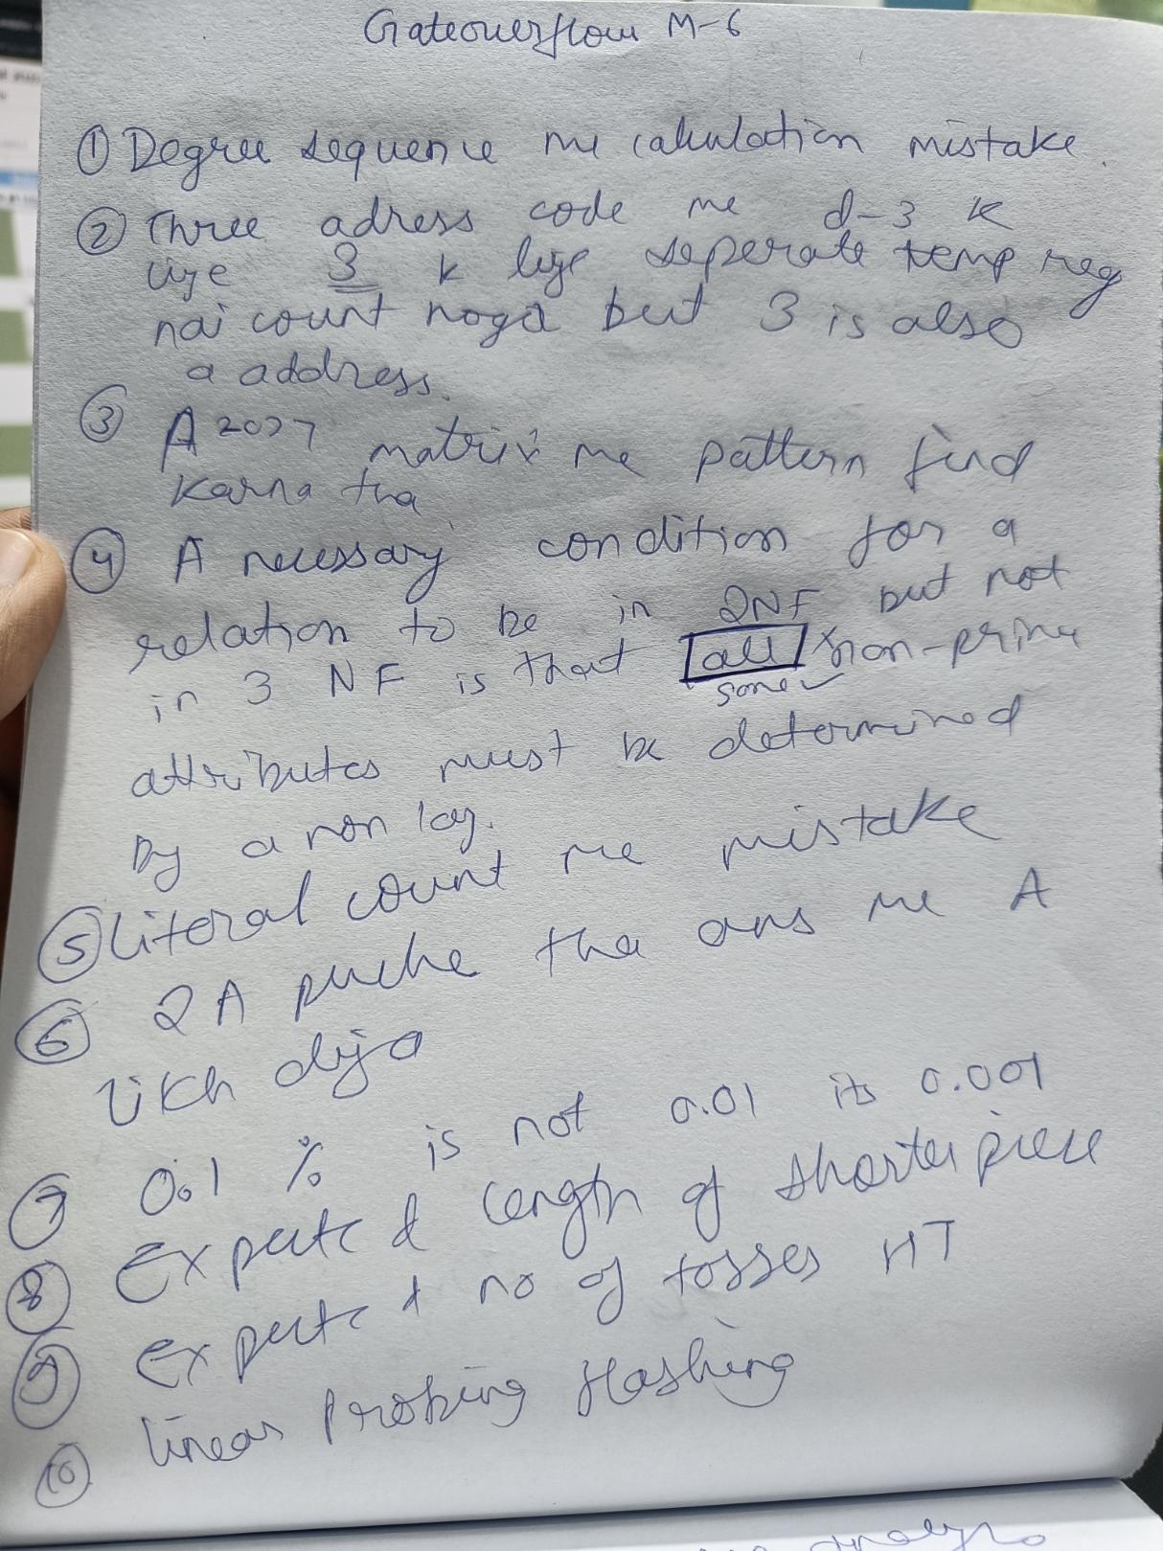
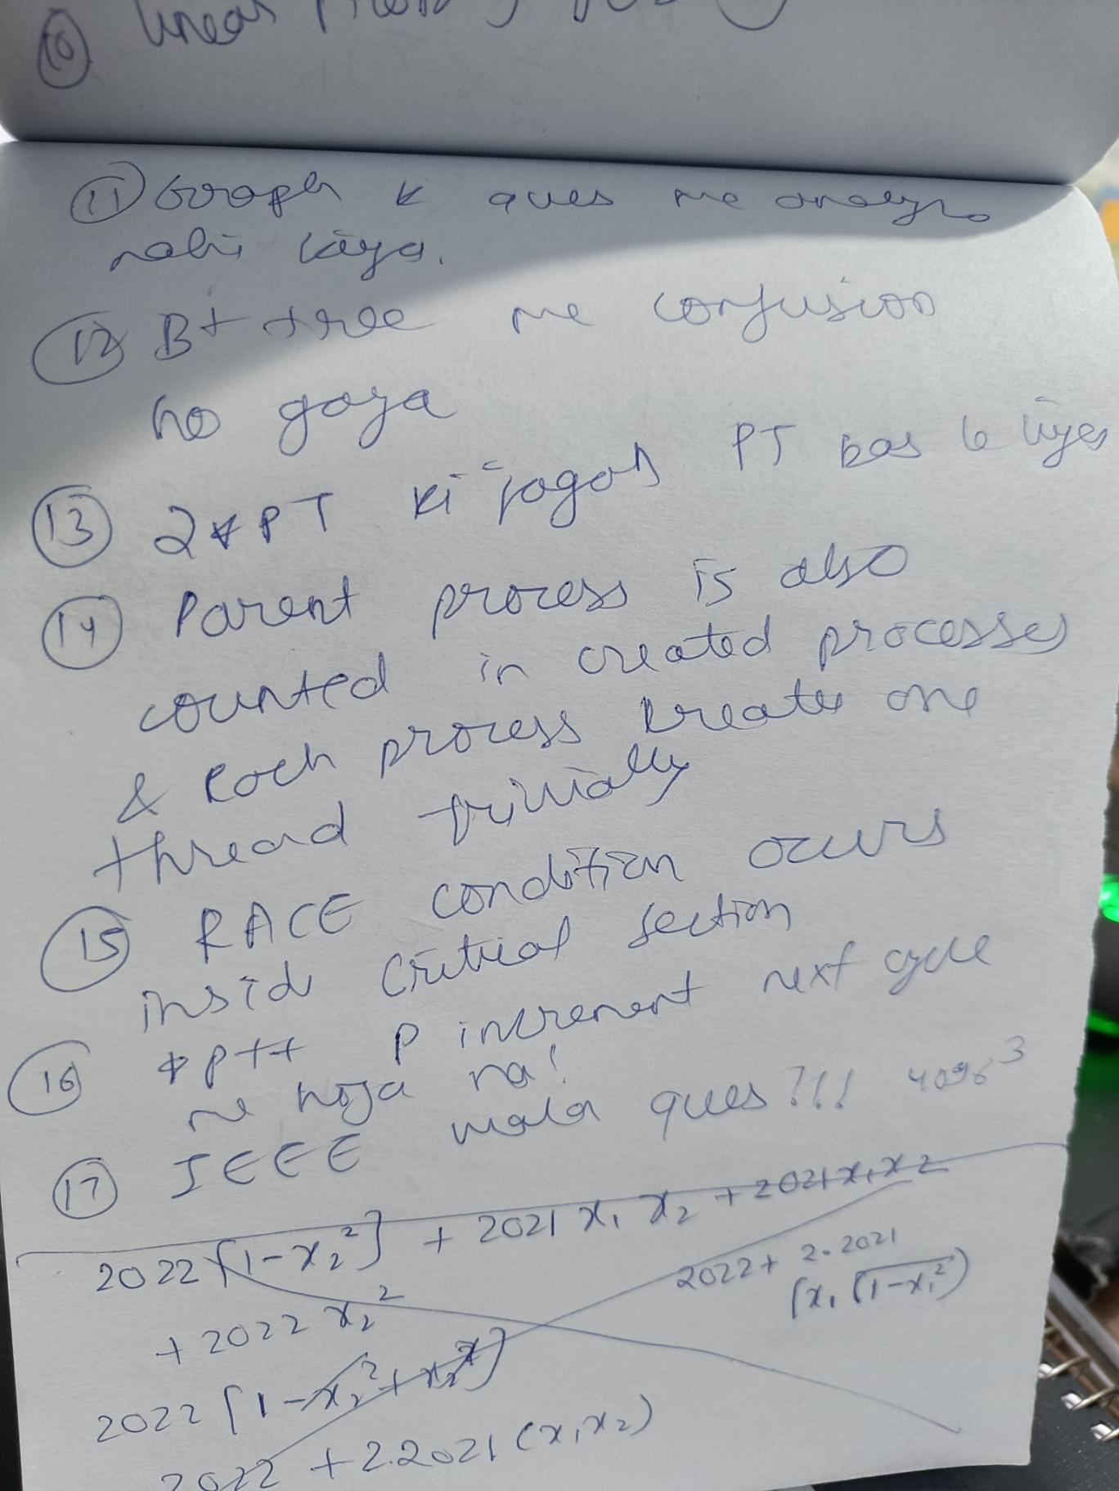
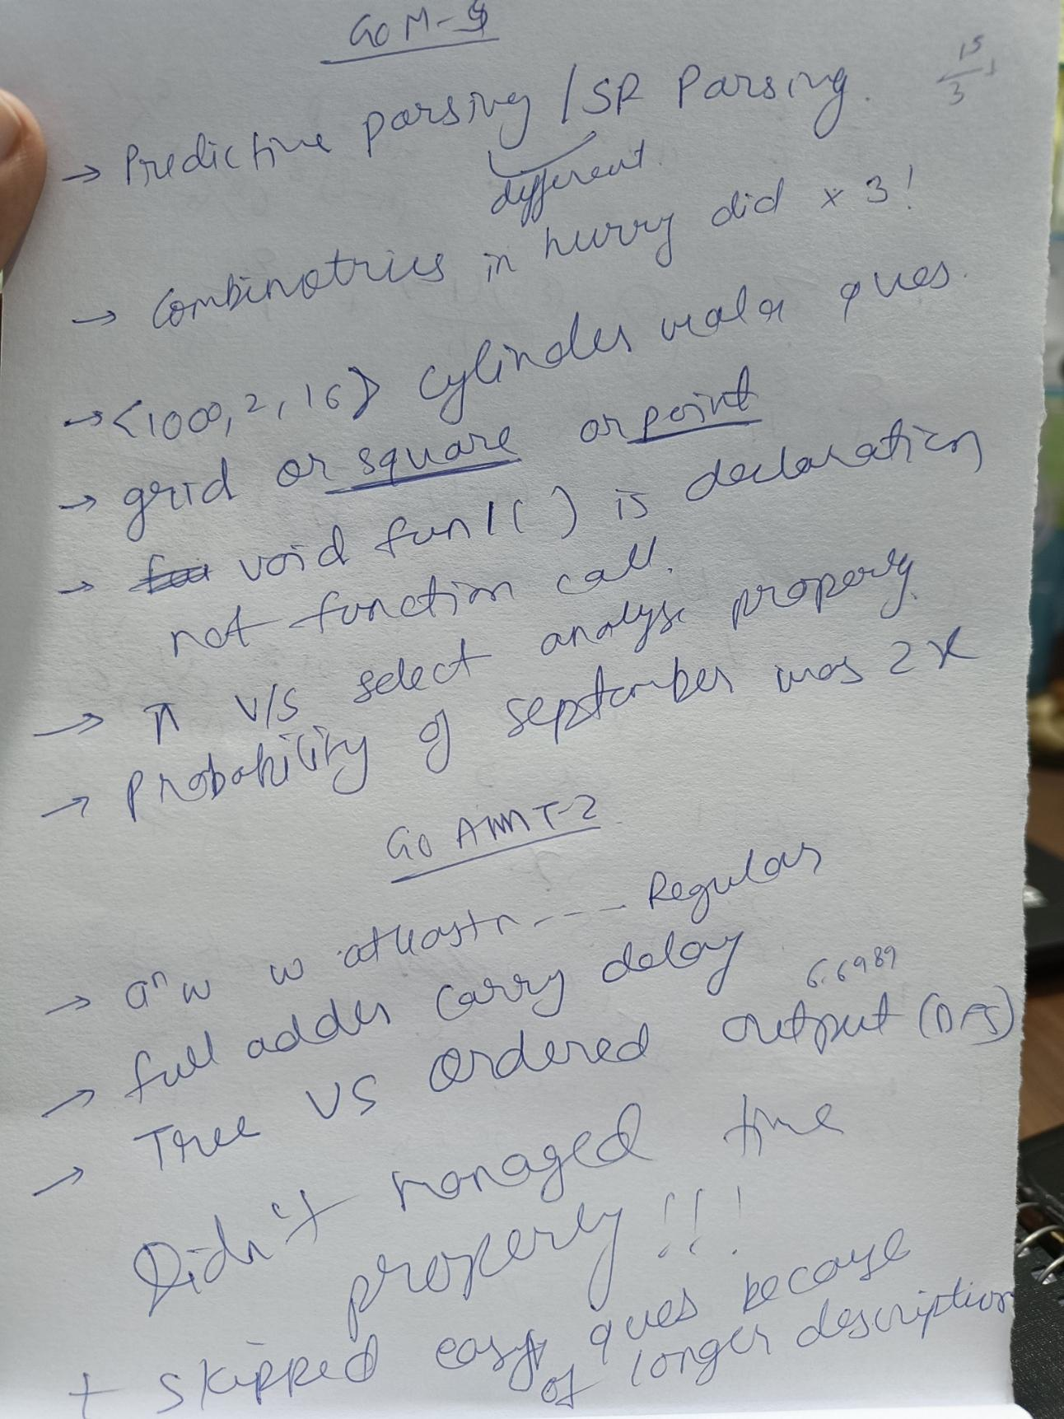
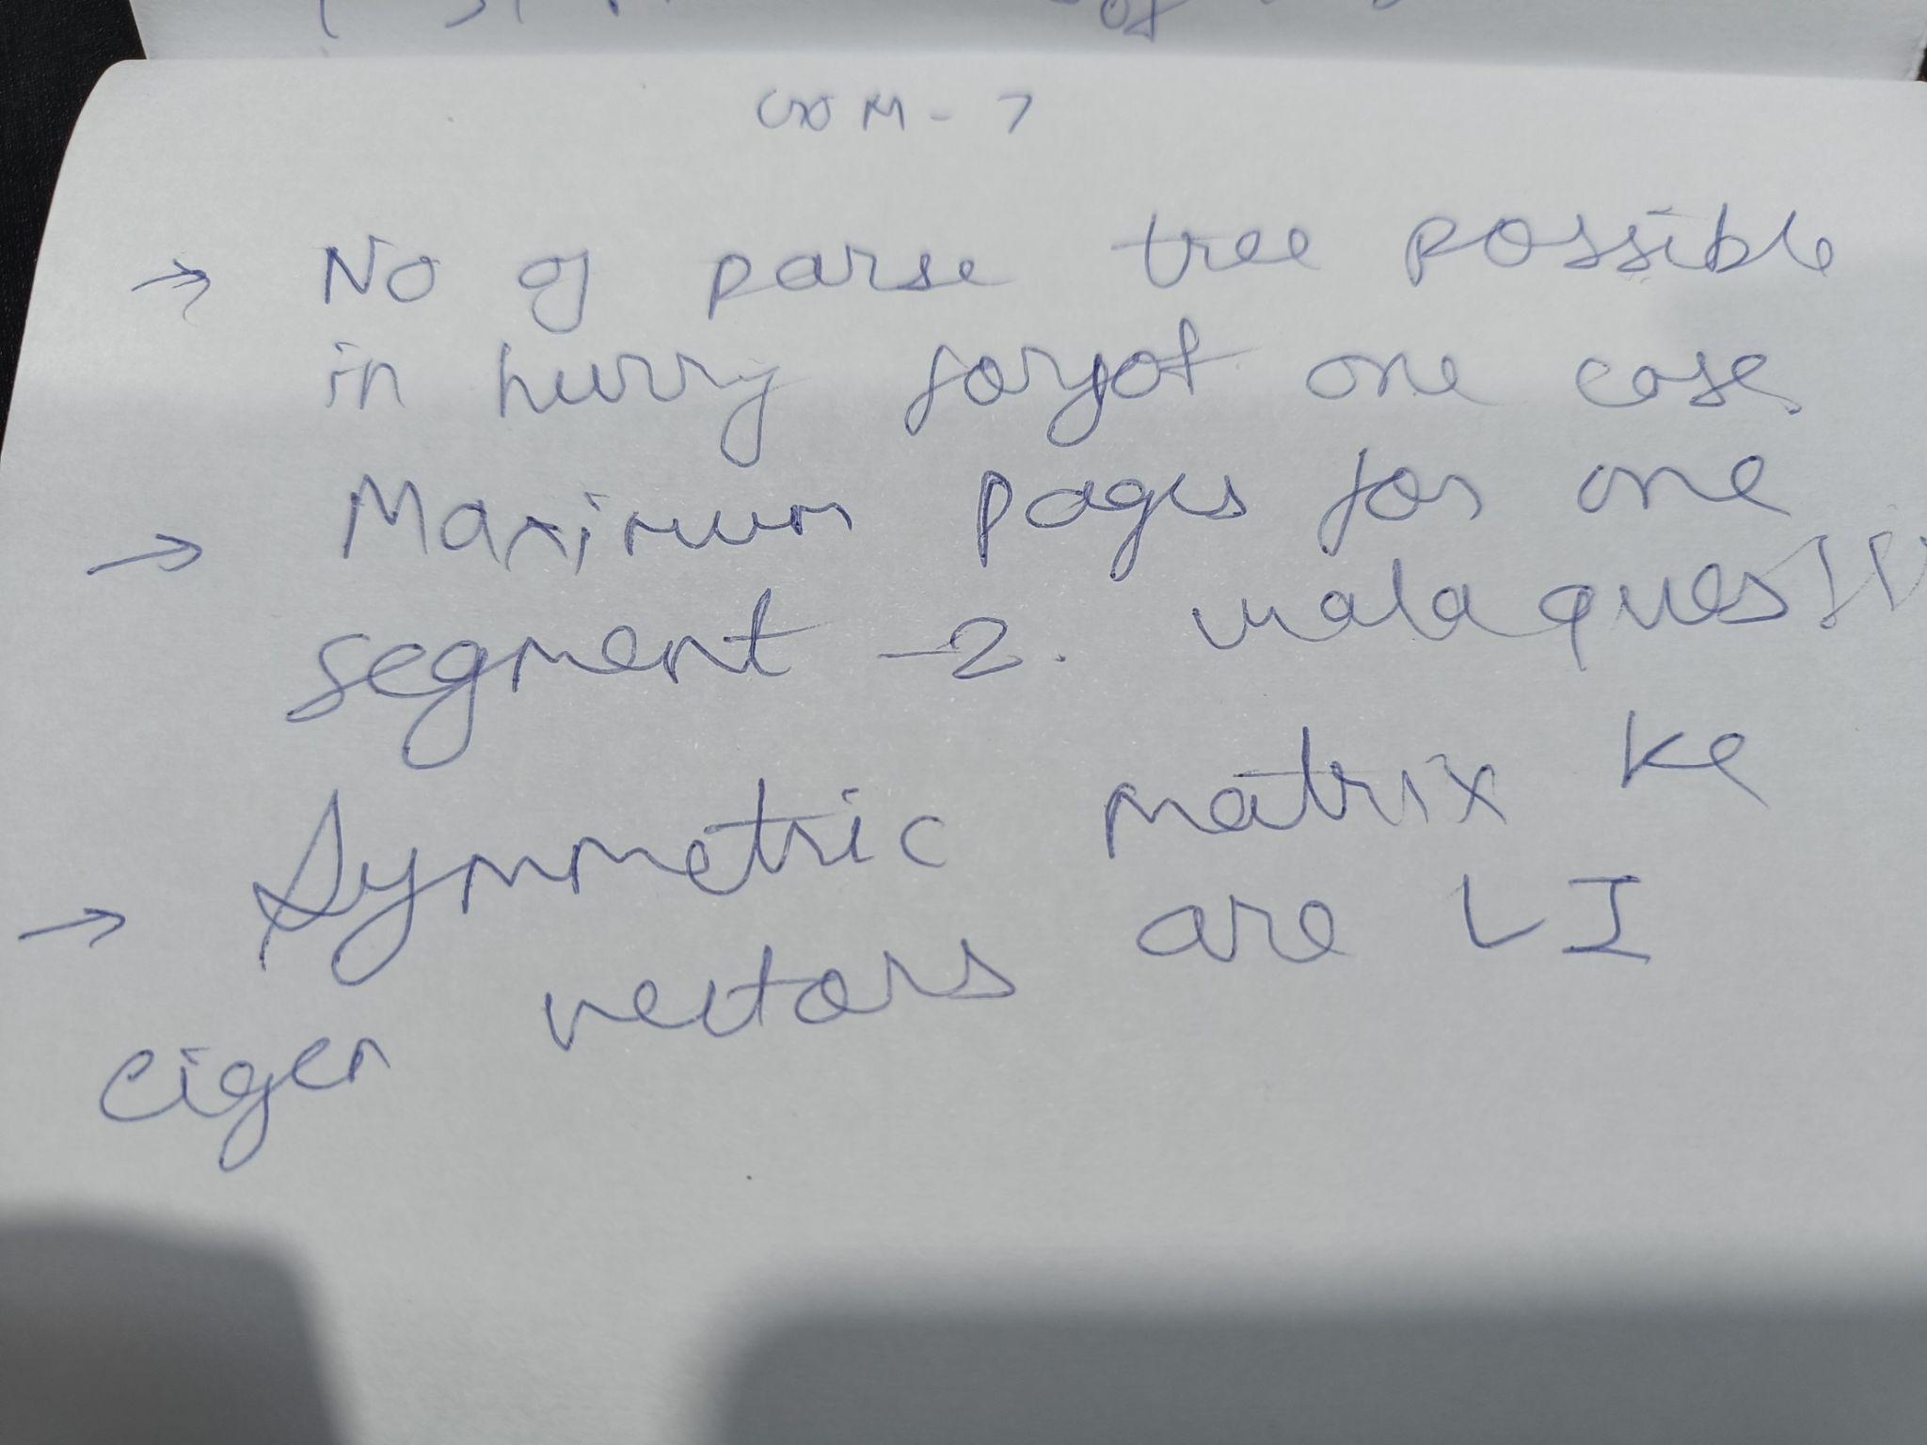
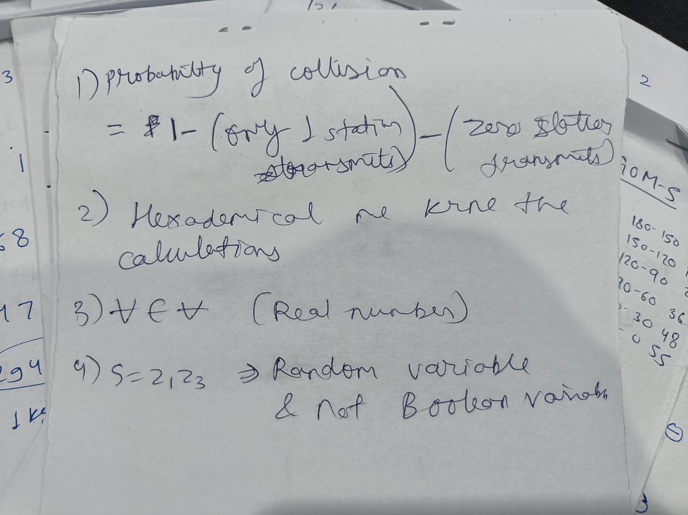

- Idempotent property : A+A=A, A.A=A
- To detect and correct ‘d’ errors the minimum hamming distance must be ‘d+1’ and ‘2d+1’ respectively.
(Here MINIMUM hamming distance is considered not MAXIMUM)
- Minor VS Cofactor
- In a B / B+ tree, except root node every node must me at least 50% occupied ie. every internal node must have ⌈ p / 2 ⌉ pointer and ⌈ p / 2 ⌉ - 1 keys.
- DBMS me initial read aur final write kya hota hai !!
- Full Binary tree, Complete binary tree and Almost complete binary tree.
- Probability of frame reaching safely is “q” then mean no of transmissions = 1 / q

- 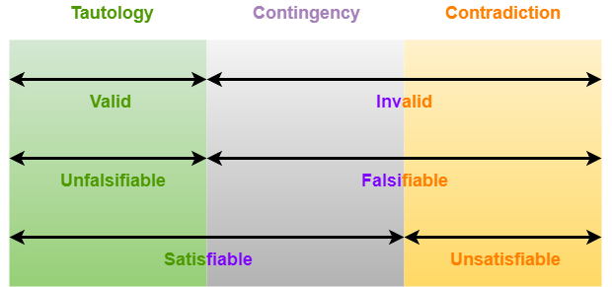
- 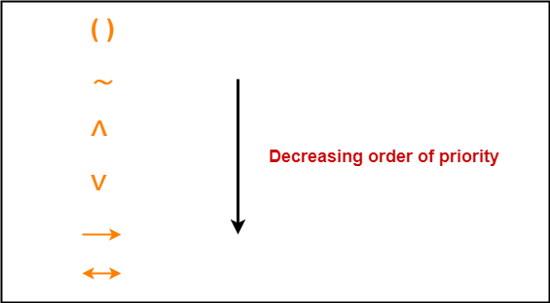
- 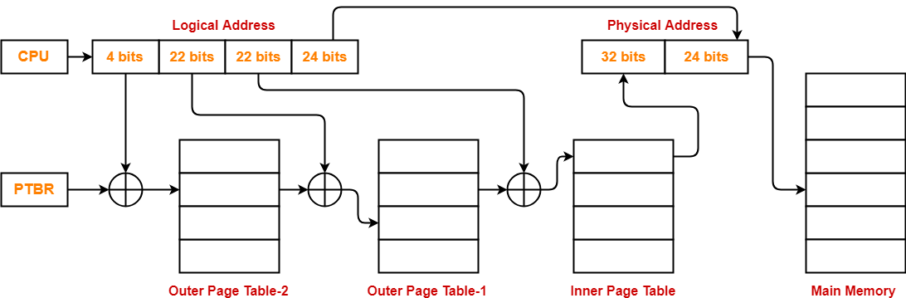
- 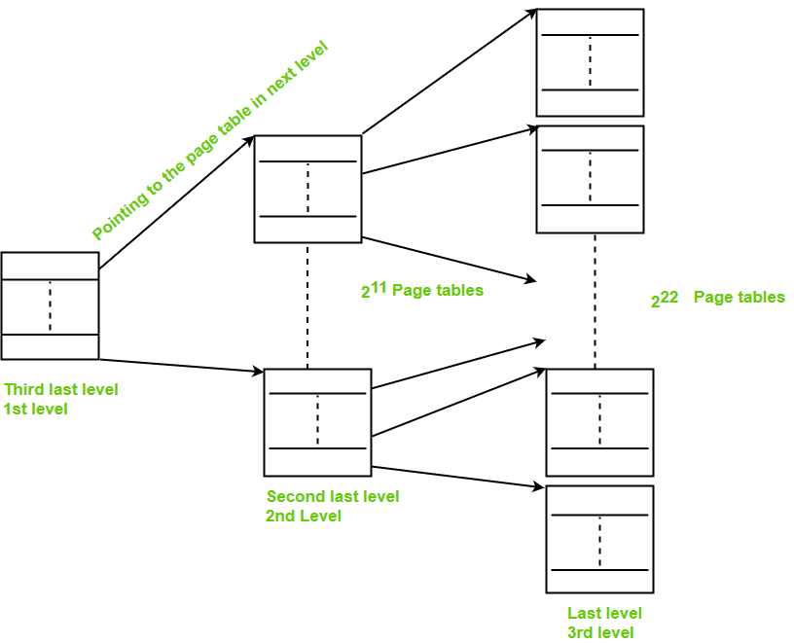
- 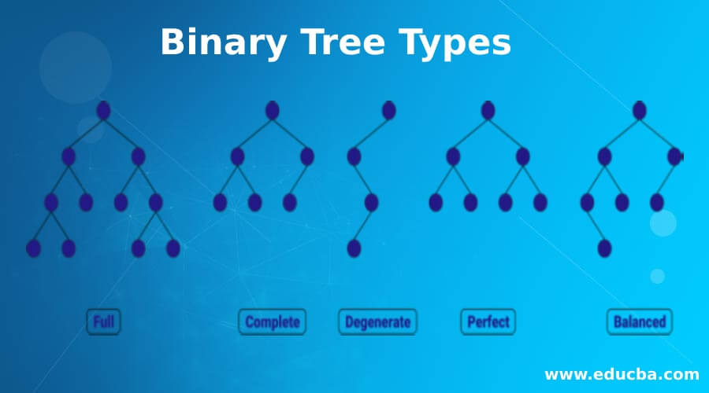
- Full binary tree and perfect binary tree : all nodes must have either 0 or 2 child. In perfect tree, maximum nodes are there.
- Complete matlab last level left to right filled.

- CAV: In this, each track consists of equal capacity & the density varies such that the innermost track has the maximum density & the outermost track has the minimum density. In CAV mode, the spindle motor turns at a constant speed, which makes the medium pass by the read/write head faster when the head is positioned at the outside of the disk.
- CLV: In this, each track consists of equal density & the capacity varies such that the innermost track has the minimum capacity & the outermost track has the maximum capacity. In CLV mode, the spindle motor speed varies so that the medium passes by the head at the same speed regardless of where on the disk the head is positioned.

FULL LENGTH TEST - 2

- https://gateoverflow.in/exam/397/go-classes-2023-mock-test-1
- Not counted the 0th clock time in the ball tolling question.
- In case of stack, push A means push the value of register A into the stack and pop A means pop the value from the stack and store it in register A.
- Datagrams are reassembled only at the destination. TRUE
- https://gateoverflow.in/387835/go-classes-test-series-2023-mock-gate-test-1-question-26 confusing MSQ on handles and viable prefix.
- Infinite solutions k baare me pucha tha but I markes about no solution.
- If some block in the liveness analysis does not have any successor then the out (S) will be empty as out = Union of IN of successors.
- Does Not analysed the ww^r CFG.

https://gateoverflow.in/387874/go-classes-test-series-2023-mock-gate-test-1-question-6

